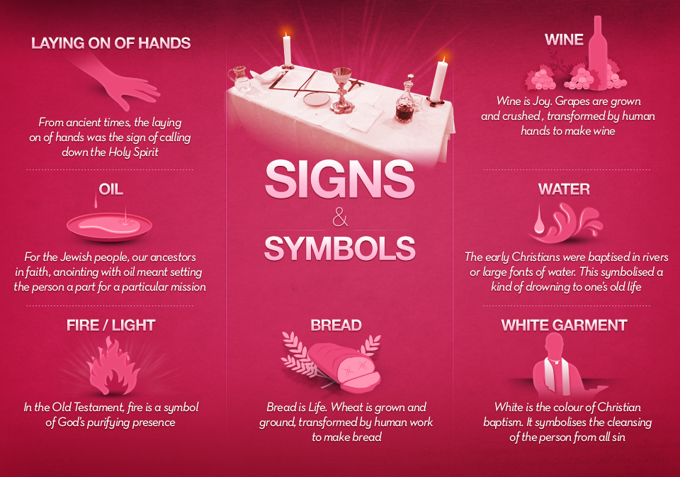
SYMBOLS USED IN RITUALS
Think about the symbols that have been used in the recent Prayer Assemblies, Opening Liturgy and College Opening Mass.

STEP 1: List some common symbols used in these rituals below and in the right hand common explain the symbolism or what their meaning.

Symbol | Meaning
Candles | The lighting of a candle represents a spiritual practice in many traditions. The flame of the candle represents God’s presents in his house (Church). Candles are often found in a place of worship or in an original place to set different moods.
Cross/Crucifix | The Cross-represents God. It represent God as he died on the cross for us to live and reminds us that we are in a sacred place and in the presents of God
Liturgical Cloths | The Liturgical Cloths represents what time of the Liturgical year it is. They can be many different colors including Green, White and Purple.
College Candle | The College candle represents our College. It symbolizes that we are all one community. That we are in the footsteps of our Saint. (St Benedicts) That we are walking with pride as we take on the name of St Benedicts.
Chalice | A Chalice is a central place of communion in worship for the Christian Church.
Water | The priest usually blesses the holy water. The water represents purity; the repentance of our sins, To have protection against evil and it is also a reminder of our baptism. To remind us that we are the children of God.
Candle Flame | The Candle flames symbolize each of the spirits.
Bread/Host | The Host symbolizes the body of the Lord. It represents him sacrificing his life for us.
Altar | The Altar represents sacrifice. The Altar is a table or a sacred place where the consecration of the bread and wine. The Consecration is where the priest blesses the bread and wine and symbolically turn them into the flesh of Jesus and blood of Jesus.
Lectern
Liturgical Colours | The Liturgical colors are supposed to bring a mood to the mass that has been put forward. Example: Purple represents in the coming of advent. Green represents ordinary times.
College Banner | Our College Banner represents us coming together as a school. Our School name is on the banner, which shows our pride throughout the name of the school.
Olive Tree | The olive trees that each PC teacher received symbolizes growth in our school community.
Icons | The different icons symbolize what we are here for today. Its represents different
Values Candle | The Value Candles show all our values among the St Benedicts community.
St Benedict’s Medal | The St Benedicts Medal

Step Two
Now create a Collage or a Prezi to include 8-10 symbols relating to Catholic Rituals. You must include pictures of the symbols and a few words to explain the meaning of the symbols. Your presentation should be visually appealing and contain the correct information about the symbols.

Use the Following Websites and Information to help you

http://www.parishes.bne.catholic.net.au/maryborough/symbols.htm
http://www.iccreligiouseducation.com/catholic_symbols.cfm
Together at One Altar -
Prezi - You will need to create an account to create your Prezi
Web 2.0 Collage Creator.- You will need to download this APP onto your computer in order to use Collage Creator to create your Symbols Presentation

