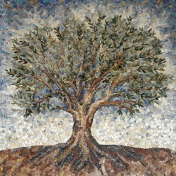
Reflection of Opening College Mass

Know | Want | How | Learn
What do I know?  I believe that when entering mass or a sacred space, we should be respectful and responsible for our own actions. There are different parts to a Mass. We all come together in the Church/Mass to be in the presence of God. We Listen to the words of wisdom that Jesus wanted us to reflect on. We also too, reflect on ourselves, for others you want to pray for and what the passage means to us. It is also respectful to bow our heads in silence as we receive God’s gifts (bread and wine) as we give thanks. Then we go forth and spread the good news. | What do I want to find out? | How can I find out what I want to learn?  I can find out what I want to learn by going to mass at least every seconde week on Sunday. This can help because you can get us | What did I learn?  From the mass on Friday, I learnt that we weren’t sent on this earth to envy the world or it’s people. We were here to help others understand things and love one another just as good asked us to do. We should always do this as this is one of his commandments. We should stick by this because it’s the right thing to do.
We Gather  We gathered in the church to have an introduction of what our school really means and what we are all about. We also gathered there to listen to the readings and scripts to reflect on it when going back to school. | We Listen  We listened to a scripture about loving others, just as God has loved his father and us. I believe the passage means that, we should all be treated equally. We shouldn’t judge others if you completely know them yet as God never taught us or wanted us to envy or disrespect others. We should never give up on others, as God wants us to lend helping hands out to the world. | We Give Thanks  We said thanks buy receiving the bread and wine or a blessing. When we had our moment of silence, I prayed for all the little things in the world and how thankful I am to have everyone. Not just my family but my all my peers, opportunities and Life. I said thanks to all the goodness God as brought upon the world and I will be forever thankful for these beautiful gifts. | We Go  Since Mass on Friday, I try everyday to make a difference. To spread the love and kindness God has wanted all of us to bring. I also smile in pride everyday to that I’m proud of myself and my achievements and who I’m made to be further on In life.
Symbols
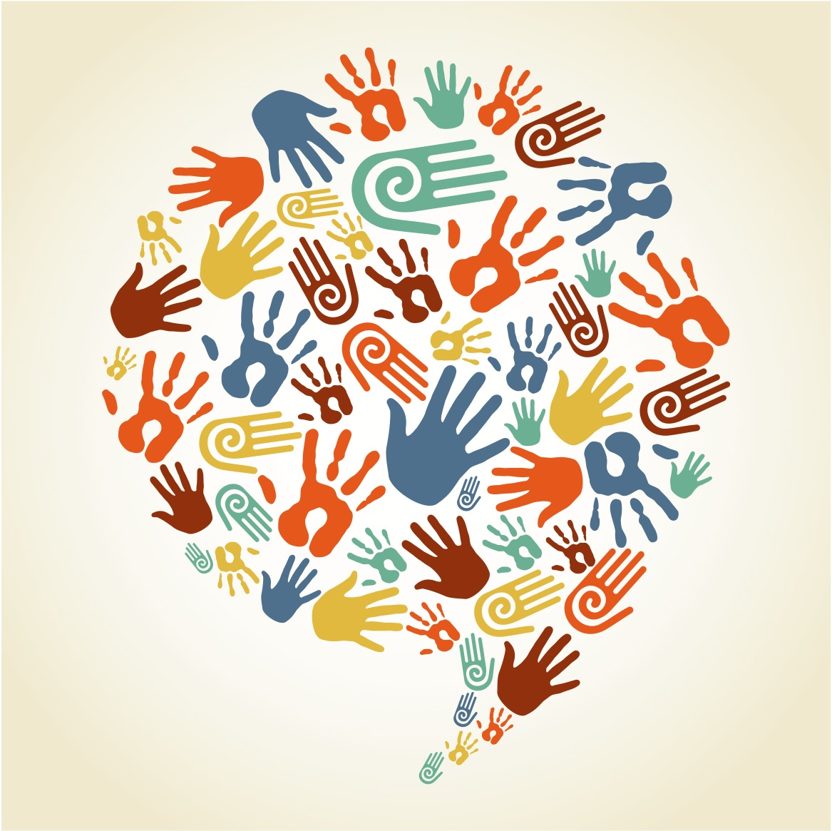 |  | 